Huntsville Alabama L5 Society (HAL5)
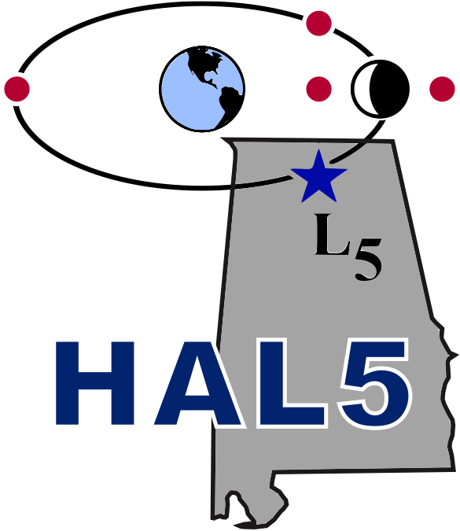 | Your local chapter of the  National Space Society  Presents | 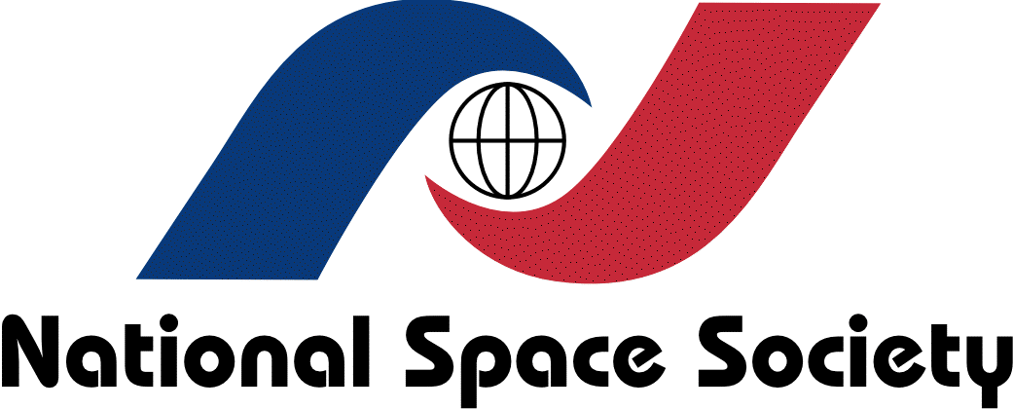

Hypersonics:
Flight of the Future
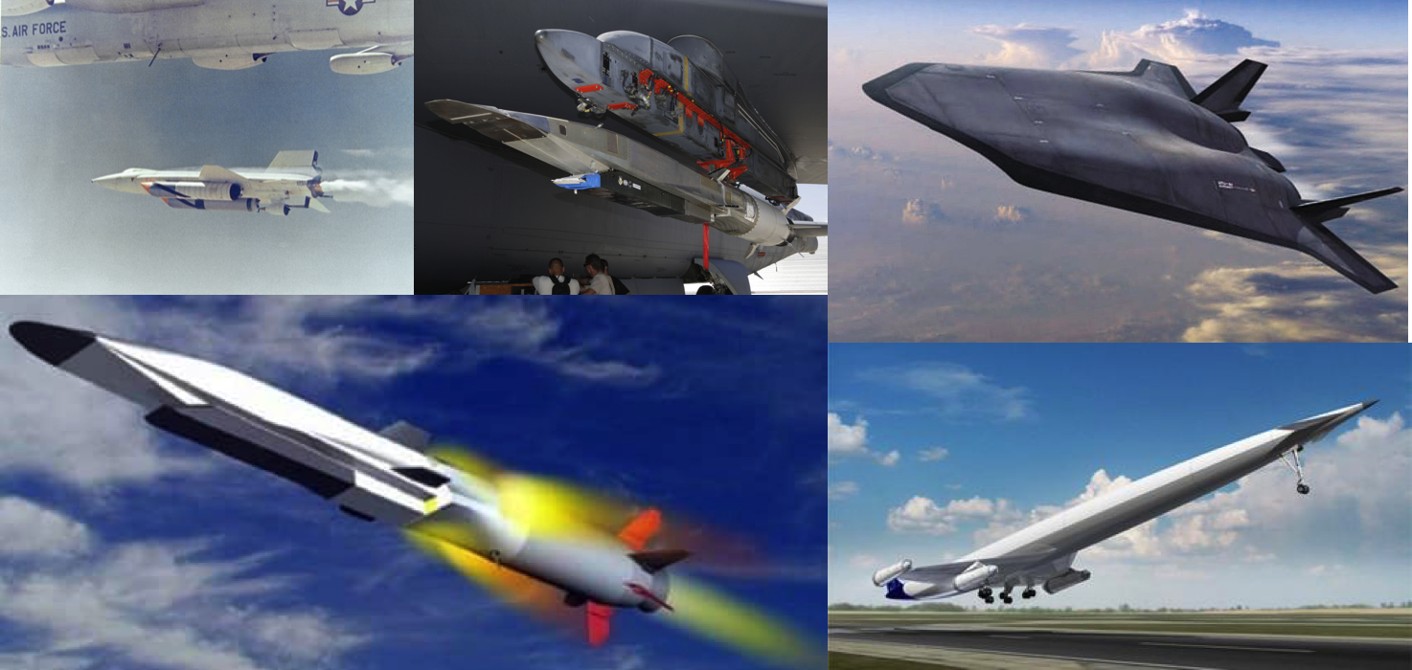
A Public Presentation by
Dr. Ragini Acharya
Sr. Principal Scientist, CFD Research Corporation
Thursday, April 5, 2018
7:00 pm to 8:30 pm at

